Development of a Nigeria Vehicle License Plate Detection System
E. A. Adedokun ¹, M. B. Mua’zu ², Iloka B .O ³ O. N. Salefu⁴, and Oyibo P.O.
^{1,2,3,4 $ 5} Department of Computer Engineering
Ahmadu Bello University,
Zaria, Nigeria.
Wale¹, mbmuazu², ousalefu4} abu.edu.ng
boluchi23, prospy_711} gmail.com

.
*Corresponding author: boluchi23@gmail.com

Abstract: The importance of license plate detection system cannot be over emphasized in intelligent transport systems. License plate is a major component in most of the applications related to intelligent transport system. Moreover, it is also a quite popular and active research topic in the field of computer vision and image processing. Different techniques and algorithms have been proposed to detect license plate number from a vehicle image. Nevertheless, due to the variation in climate conditions, characteristics of the license plate, numbering system, colors, fonts and size further work is still needed in this field in order to make the detection and recognition process accurate and very efficient. For these reasons, this paper presents a scheme for license plate detection using current image processing techniques. The developed scheme used images obtained from Caltech database and our newly acquired Ahmadu Bello University (ABU) dataset. To detect the license plate, the acquired images were pre-processed to reduce the computational requirement of the developed scheme. Canny operation was performed to detect the edge of the pre-processed images then histogram equalization was applied to spread out the contrast of the image. Edged information was used to extract the region which constituted the license plate number and lastly Support Vector Machine (SVM) was used to distinguish the true license plate from other regions. The performance of the developed scheme was evaluated on the Caltech dataset and the ABU dataset. The experimental result shows that our model achieved a better detection rate accuracy than some existing methods

Keywords: Image processing, license plate, Histogram equalization, Edge detection, Sport Vector Machine.

1. INTRODUCTION
The role of Automatic licensed plate detection system (ALPDS) cannot be over emphasized in the world today, this is due to the important role it plays in intelligent transport system with the development of smart city. ALPDS is applicable in areas like automatic toll collection, access control, and traffic monitoring system [4] .License plate number detection has attracted good research interest in academic and industrial communities. Although great progress have been have been made during the past decades. The first automatic licensed plate recognition system was established in 1976 at the police scientific development branch in the UK,[12] then, the functionality of license plate recognition system was very limited. The initial intention of number plate recognition in Police Force is to prevent unlicensed and auto thefts. Police forces were provided with vehicles mounted with car plate recognition technology. In 2007 United States in cooperated the ALPR into the red light camera network technology to apprehend drivers whose vehicle drove passed the red traffic lights [10] .However, despite many algorithms that have been proposed for license plate detection systems, there are needs to develop more complex algorithms to tackle some challenges associated with license plate detection such as plate variation, size, color, font, occlusion, inclination angle, and environmental variation which includes change in illumination and background, weather conditions, lighting conditions, and even camera conditions may contribute to this problem.
License plate detection uses basic image processing tools and computer vision techniques to successfully detect the exact position of a LP from a vehicle image.

2. SIMILAR LITERATURE
Similar works have been carried out in the area of license plate detection. This review is carried out to understand the extent of research in this area, tools and approaches used. The knowledge gained facilitate this research work by using different tool and approach to get better result. The different system proposed in LP detection are based on different image processing techniques. Some techniques combines one or more approach to achieve a better detection performance while some opt for a machine learning algorithm. The techniques is based on the following edge information, texture base, colour information, character based and morphological operations[13].Although deep learning algorithm have been successful applied to license plate detecting tasks [7] they generally require a large number of training samples, seems there are no large dataset available it is difficult to improve the accuracy by using deep models. Many promising algorithms were proposed to perform similar task despite the unavailability of larger dataset.[1] Presented an automatic vehicle license plate detection and classification system using the colour information of the license plate, in their work vehicles were classified into government, commercial or private vehicles based on the colour of the plate. They applied various pre-processing operation such as grayscale conversion, mean filter to remove noise from the acquired images. [14] Proposed a license plate detection system using feature descriptor based on colour saliency features of the license plate to detect the region of the license plate on the vehicle image. In their work the input colour image is resized and converted to grayscale image. Sobel operator was used to detect the edges of the image and adaptive thresholding is applied to binaries the edge image. Finally, a line density filter which uses the edge information of the license plate was applied to extract the candidates’ region. To distinguish the candidate region from other regions on the image, geometric attributes of the plate was used. To classify the final license plate region from the other detected regions a cascaded license plate classifier (CLPC) was used to classify the true license plate from the other candidates. [5] Proposed a license plate detection algorithm using morphological opening and closing techniques. The method consisted of the following steps, pre-processing, adaptive morphological closing (AMC), local adaptive thresholding (LAT) and adaptive morphological opening (AMO). Histogram equalization is used to enhance the image contrast and AMO operation such as dilation and erosion is applied to disconnect region of weak junctions. The local adaptive thresholding (LAT) is used to segment the image. However, the proposed approach is not suitable for real time applications because of the time-consuming nature of the morphological operations. Other approaches have also been used, which represent a combination of two or more methods, named hybrid approaches.[10] Presented a license plate detection system that is capable of detecting a Bangla number plate using morphological operation and color information of the license plate. In their work the input image was converted to binary image and then closing operation was used to fill the connected using, contour algorithm and aspect ratio was used to locate the license plate region while opening operation was used to dilate the image based on the structural element.Li and chan trained a CNN based on characters cropped from general text to perform character based LP detection. However, they achieved a higher Recall and precision rate than the previous approach in the expense of large available datasets.

3. PROPOSED METHODOLOGY
The proposed experiment will be conducted on Matrix Laboratory (MATLAB) R2018b simulation used for image analysis. The following steps will be considered in carrying out the processes.

Algorithm
Step1. Image Acquisition-Capture the image through digital camera and given as an input to the process.

Step2. Converting of Color image to gray scale image

Step 3. Image Enhancement- Removing of noise using median filter and equalizing the image contrast

Step 4. Edge detection- canny edge detector was used to find the boundaries that constitue the license plate region

Step 5.License plate localization by appending a fixed bounding box on the detected regions

Step 6. The license plate region is finally extracted based on the pre-defined features

Step 7. Final verification of the true license plates from other candidates

Figure 1: Flowchart of the proposed work

3.1. Methodology
In this section, the materials and methods employed for the successful completion of this research are discussed. The methodology adopted for the development of the vehicle license detection is also presented.

3.1.1. Image Acquisition
The first stage of license plate detection system is image acquisition. Images of rear and front view of vehicle are captured using a high resolution digital camera. These images are captured at a resolution of 300 x 1508 pixels with a Nikon D40 camera specification. Other publicly available databases such as the Caltech dataset were also collated and used to evaluate the robustness of the proposed work. The ABU dataset contain 250 images of front and rear view of vehicle captured in Ahmadu Bello University and 350 images collated from the Caltech 101 dataset repository [3].

3.1.2. Image-preprocessing
In-order to enhance the acquired image certain pre-processing operations are applied to the image thereby improving its quality so as to enhance the detection performance of the algorithm. These techniques are applied to remove shadows and noise from the image. However, the quality of the image is a major factor that guarantees the efficiency and accuracy of the algorithm [4]. The following pre-processing operations were applied to the image.

3. 1.3. RGB to grayscale conversion:
Grayscale conversion is used to convert colored images to the gray scale image by calculating the value of the gray level [6].This technique is very important in license plate detection system because using the original colored image increases the processing time of the algorithm and occupy more space on the system memory. The conversion was done using equation 1: [13]
(1)
Where R, G and B represent Red, Green and Blue component respectively.
3.1.4. Noise removal
Noises in digital images are unwanted signals that cause distraction in the image. Image distortion is the most significant problem in image processing and can be caused by various types of noise such as Gaussian noise, Poisson noise, salt and pepper noise etc.[2] .However license plate are associated with salt and papper noise which was removed using a median filter.

$f\left(x,y\right)=median\{ g(s,t$)} (2)
Where f(x,y) is the filtered image g(s,t) represent the noisy image

3.1.5. Histogram equalization:
Histogram equalization is an image transformation technique that is used for detail enhancement. This technique computes a histogram of every intensity level in a given image and stretches it to obtain uniformly distributed intensities [7].The output image will yield image with uniformly distributed pixels than the original image.
$$s_{k= \frac{l-1}{N}}\sum_{I=0}^{κ}{n_{i}}κ=0,1,2,….…..L- \left(3\right)$$
Where $s_{k}$ is new value for transformed Pixel. $Ν$ and $n_{i}$ are number of pixels and number of pixel with value$=i,$ respectively.

3.1.6. Edge detection
Seems vehicle License plate are characterized by abundant edge information, the edges and boundaries of the license plates can be used to detect the position of the plate in a given image. This edge information was extracted by applying canny operator. Other widely used operators such as sobel, Prewith, Robert and laplacians are sensitive to noise. The proposed canny edge detector uses Gaussian function to smoothing or for the convolution of the original image there by reducing the effect of the noise on the image.

3.1.7. Image localization
The main aim of this stage is to identify the exact location of the license plate region in the digital image, the result is a sub-image that contains only the vehicle license number plate. This can be achieved in two steps.
a. Determining the exact location of the license plate using the edge information of the plate.
b. Locating a large bounding rectangle over the license plate using the size, aspect ratio and area of the license plate number.

3.1.8. Region of interest extraction
The region of interest is the area that constitute the properties of a license plate, such region are identify based on the size and shape of the object. License plate are usually rectangular and mostly of a fixed aspect ratio and sizes, thus the distinct shape is considered when extracting the license plate true region.

3.1.9. Support vector machine
If the license plate area are to be found by using only the size and the aspect ratio, it cannot be detected accurately because objects with similar sizes and aspect ratio are detected together. Solve this problem a classification method is used to classify the detected regions. There are various classification algorithms to solve this problem. In this paper, SVM, which is one of the machine learning algorithms, is used to detect the license plate area.

4. EXPERIMENTAL RESULTS
In this section, some experiments are conducted to demonstrate the effectiveness of the proposed model for the detection of license plate number. All the experiment were performed on a core i7 computer running on Matlab 2018b. The experiments were conducted in two dataset containing 350 images obtained from Caltech image repository [3] and 250 vehicle images obtained from Ahmadu Bello University (ABU) dataset. The lack of limited number of datasets hinders the application of some powerful dep learning models. In our experiment we collected images of single and multiple vehicles captured under various environmental conditions. Samples images from the two datasets used for the evaluation of the scheme is depicted in Figure 1. The performance of the proposed method was evaluated using detection rate, precision and recall and accuracy as the performance matrices.

4.1. Datasets
The images of the vehicle that made up the dataset are depicted in figure 2: these images contain vehicle captured under various environment condition, single and multiple vehicle etc.
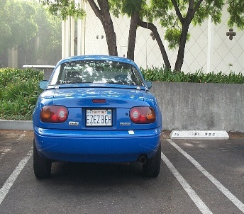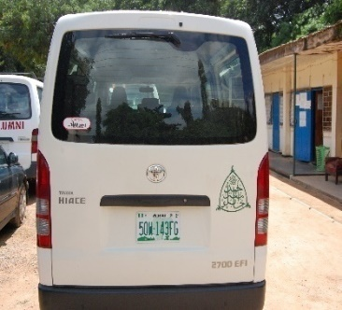

(a) Caltech Vehicle image (b) ABU Vehicle image (c) ABU Multiple image
Figure 2: Examples of acquired images from the Caltech and ABU dataset

4.1. Detection result
The process of license plate detection illustrated in Figure 3: shows the various steps in the license plate detection and the result of the detection rate is given in Table 1 with a comparison of other methods.
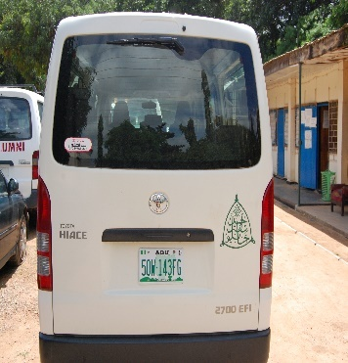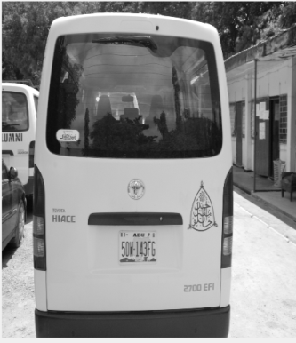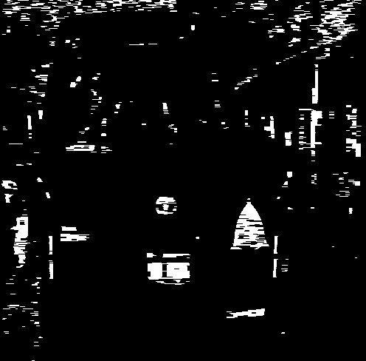
- Colored image (b) Grayscale image (C) binary gradient image using Canny
Edged detector
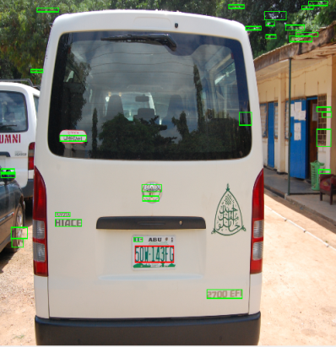
(d) Identified region of interest (e) Extracted license plate number

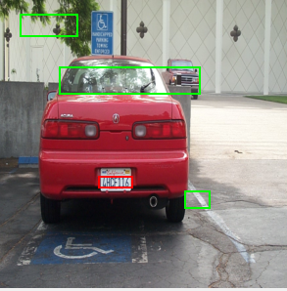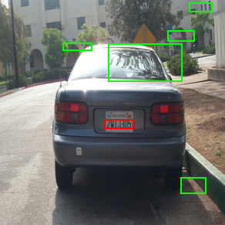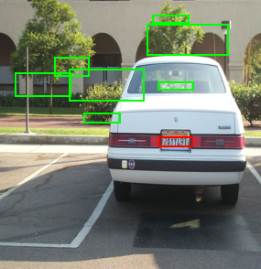
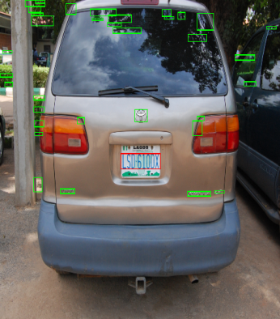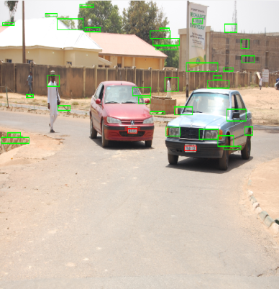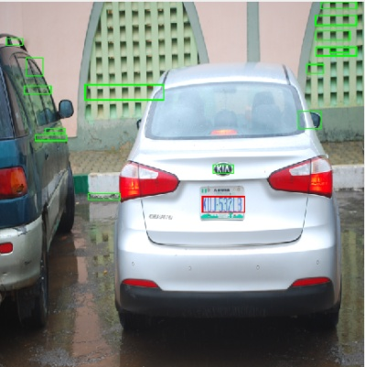
Figure 4: Samples of the images of the Caltech and ABU dataset with the corresponding bounding boxes. First row show the detected license plate of the Caltech dataset while second rows shows that of the ABU dataset. The green box represent the candidate region while the red box represent the detected region of interest.

s
Figure 5: License plate from the two datasets properly extracted

Table 1: Detection results obtained by the proposed system on the ABU and Caltech dataset
Dataset | DETECTION RATE  (%) | EXTRACTION RATE (%) | PRECISION (%) | RECALL (%)
Caltech | 98 | 100 | 96 | 92
ABU | 96 | 100 | 98 | 97

We note that the algorithm achieved a detection rate of 98% when evaluated on the caltech dataset and 96% when evaluated on the ABU dataset, likewise the extraction processes achieved a 100% in extracting the number plate using both dataset. However we can conclude that our algorithm performed well during the extraction process. Examples of some failed detection is depicted in figure 6:
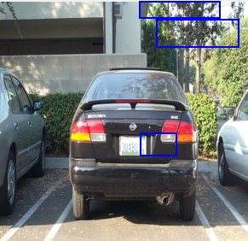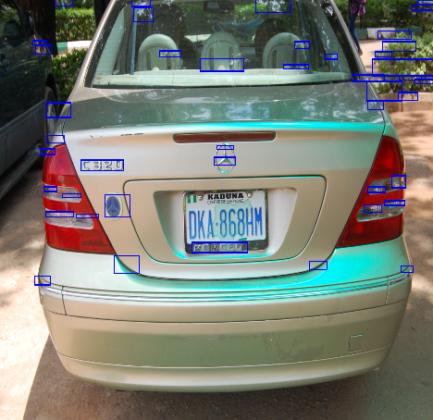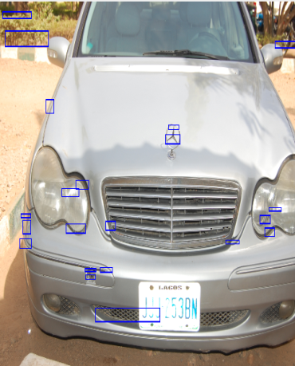
Figure 6: Samples of failed detection
The failed detection was as a result of some factors such as the distance between the car and the capturing device, the illumination conditions. However a fixed distance between the car and the camera would be able to solve this problem.
5. CONCLUSION
In this paper basic image processing and computer vision tools were used to detect and extract the number plate from a given vehicle image. The license plate detection is the most important stage in an automatic license plate recognition system, its accuracy determines the overall performance of the system. Images of vehicles are acquired under various environmental conditions thus detecting the exact location of the license plate becomes a difficult task due to the varying weather, hence limit the functionality of the algorithm. The proposed algorithm consists of four stages: edge detection, candidate extraction, candidate verification using area and aspect ratio of the plate and final verification method using a classical machine learning algorithm for classification of the license plate regions. The experimental results has demonstrated the effectiveness of the proposed in tackling this problem when larger amount of data is not available for effective training of the classifier. Our approach is robust when tested on the dataset .However, standard data augmentation methods can be employ in-order to utilize the deep learning architecture when there are limited amount of dataset available.

ACKNOWLEDGMENT
I am deeply grateful to the leaders and members of the computer and control research group of the Department of Computer Engineering, Faculty of Engineering, Ahmadu Bello University, Zaria for their effort, guidance and constant supervision they accorded me towards the successful completion of this work. This would not have been possible without their valuable contributions and assistance.

REFERENCES
- Attah, A. B. A. A. . & A. A. M. (2016). Development of Nigeria Vehicle License Plate Recognition and Classification System, 12(1), 125–133.

- Boyat, A. K., & Joshi, B. K. (2015). A Review Paper : Noise Models in Digital Image Processing, 6(2), 63–75.

- Caltech. (2005). Computational Vision: Archive. Retrieved from http://www.vision.caltech.edu/Image Datasets/cars markus/cars markus.tar

- Du, S., Ibrahim, M., Shehata, M., & Member, S. (2013). Automatic License Plate Recognition ( ALPR ): A State-of-the-Art Review, 23(2).

- Fomani, &shahbahrami. (2017). License Plate Detection using Adaptive Morphological Closing and Local Adaptive Thresholding, (Ipria), 146–150.

- Fisher, R., Perkins, S., Walker, A. and Wolfart, E. (2003). Grayscale Images , Available at: https://homepages.inf.ed.ac.uk/rbf/HIPR2/gryimage.htm.

- Han, P. U., Han, W. E., Wang, D., & Zhai, Y. (2003). Car license plate feature extraction and recognition based on multi-stage classifier. Proceedings of the 2003 International Conference on Machine Learning and Cybernetics (IEEE Cat. No.03EX693), (November), 128–132. https://doi.org/10.1109/ICMLC.2003.1264456

- H. Li and C. Shun “Reading car license plate using deep convolutional neural network and LSTMs” CoRR, vol. abs/1601.05610, 2016 . [online] Available http://arxiv.org/abs/1601.05610

- Hossen, M. K., Roy, A. C., Chowdhury, S. A., & Deb, K. (2018). License Plate Detection and Recognition System based on Morphological Approach and Feed-Forward Neural Network, 18(5), 36–45.
[10 J]enkins, H. . (2007). Wall Street Journal (Eastern edition), January 31, 2007, A12. Business World: Future of Driving
- LeCun . Y, Bengio . Y, G . Hinton, Deep learning, Nature. 521 (7553) (2015) 436-444

- Nguwi, Y. Y., & Lim, W. J. (2015). Number Plate Recognition in Noisy Image, (Cisp), 476–480.

- Saravanan, C. (2010). Color image to grayscale image conversion. 2010 2nd International Conference on Computer Engineering and Applications, ICCEA 2010, 2(June), 196–199. https://doi.org/10.1109/ICCEA.2010.192

- Yuan, Y., Zou, W., Zhao, Y., Wang, X., Hu, X., & Komodakis, N. (2016). A Robust and Efficient Approach to License Plate Detection, 7149(c), 1–13.https://doi.org/10.1109/TIP.2016.26.190

- Zhao, Y., Yuan, Y., Bai, S., Liu, K., & Fang, W. (2011). Voting-based license plate location. IEEE Conference on Intelligent Transportation Systems, Proceedings, ITSC, 314–317. https://doi.org/10.1109/ITSC.2011.6082854

